*Historical RAKSHAGALA MOUNTAIN.*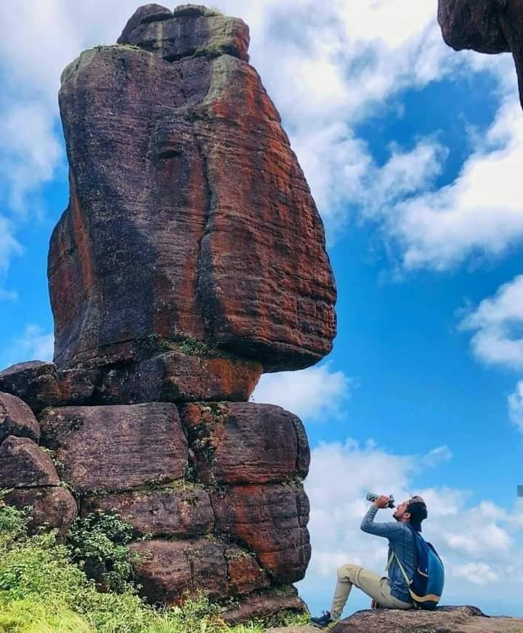

Figure

Table of Contents

*Historical RAKSHAGALA MOUNTAIN.* 1

Introduction of the Rakshagala Mountain 3

Natural beauty of Rakshagala Mountain. 4

• Environmental adaptations. 4

• “Dethiri” Waterfall 5

• “Ma Oya” 5

• “Algae “attached to rocks. 6

Topographic Features of Rakshagala Mountain. 7

Biodiversity of Rakshagala area. 8

• Maharathmal. 10

• Kadulassa. 10

• Ferns. 11

• Mango. 11

• Banyan trees. 12

• Phineas nuts. 12

• Veralu. 12

• Phineas. 12

Plant varieties 13

• Mana plants. 13

• Heinbovitiya . 14

Animal Diversity. 14

• Purple faced languor. 14

• Monky. 15

• Giant Squirrels. 15

• Jungleflow. 16

• Myna. 16

A beautiful creation of nature. 17

Aim of my project. 18

All of the location details. 18

Referenses. 19

Introduction of the Rakshagala Mountain.

**R**

**akshagala Mountain**, which is said to be an iron forge of king Ravana, is known by the names of “paththini Amma” mountain, wangedi molgus gala (mortar pestle rock) which is a heritage of Sri Lanka’s rich history. It is believed that before load Buddha come to Sri Lankan the 3 tribes of Yaksha, Naga, and Deva lived in this land. Among them, the Rakshagala is believed to have been inhabited by the Yaksha tribe. Therefore, the area with this mountain is called “Rakshagala”.This because the iron forge of king Ravana was used to build weapons in this station, And due to these facts, this mountain is also known as “kinihira Mountain”. Another name for this mountain is “wangedi molgus”mountain. It got its name because this mountain looks like a wangedi (mortar) and a molgus (pestle) from a distance. Rakshagala Mountain is known by the above mentioned names and Rakshagala is said to be inherited from a long history. According to the history of Sri Lankan, Rakshagala can be called as a place with high biological diversity on the basis of archaeological evidence. As an administrative name, the area of Rakshagala located in Nawalapitiya constituency of Kandy district has an area of about 450 acres. Rakshagala Mountain is the second highest mountain in the mountain range of Dolosbage, about 1438m high. The big rocks on top of this mountain add a wonderful shape to the environment.

Rakshagala Mountain is mostly associated with the Ravana era. The special feature of this mountain is that the entire mountain area is covered with forest. A perfect hiding place for anyone. King Ravana abducted princess sitha from India and during the 12years that princess sitha lived in Sri Lanka,she hid her in places like Sitha Eliya ,Ravana Falls, as well as Rakshagala Kanda in the Rakshagala area. Due to these facts,it is an important fact that the villages of that area have been given many names.

The stone pillars in the Rakshagala Mountain have been created as a suitable environment for anyone to hide. This area with a large forest helped king Ravana to escape from the attacks. There are many tunnels on these stone pillars. There are many tunnels on the stone pillars on the top of Rakshagala Mountain .The preserved hilltop consists of several stone pillars of various shapes. The significance of the Rakshagala Mountain is that it is used as a side route to Adams ‘peak.

# 

# Natural beauty of Rakshagala Mountain.

## Environmental adaptations.

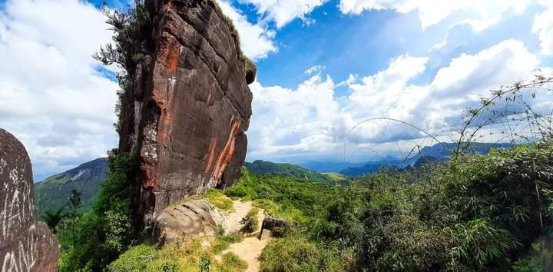

Figure

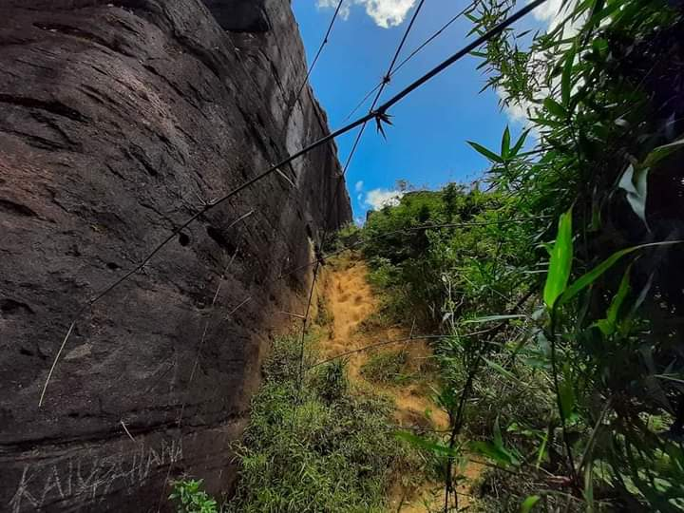

Figure

**R**

**akshagala Mountain** is a very important water catchment area. “MA oya”whitch starts from this area is a unique example.”Maoya”flows from Rakshagala and paragala, Kandakade, areas.”Maoya”start from Kinihira kanda.The specialty of “Maoya”is that there is stone called ‘manikkota’all over this maoya.Although those stones were precious gams in the past, today they are a king of stone. That kind of stone has expired by now. Due to Rakshagala Mountain, this is a water catchment area, the ‘Dethiri Falls ‘which flows from Galamuduna is also important. An inscription is also found in the southern direction of Rakshagala Mountain and no one has consulted it.There is no written evidence to confirm the history of Mount Rakshagala and it is based on archaeological evidence alone.

## “Dethiri” Waterfall

Figure

## “Ma Oya”

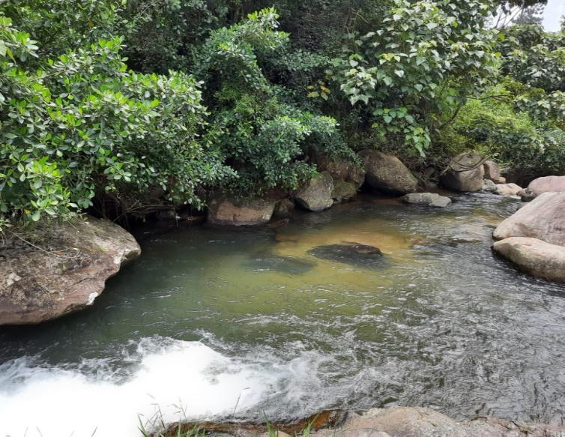

Figure

of **Forests** found in mountainous areas above 1200m above sea level belong to mountain forests. Mount Rakshagala also belongs to this forest category. More than 3500m of rain falls throughout the year and it works as little or no in every month throughout the year. Therefore, most of the plant here are compact in nature. Also has a coiled and branched unidirectional nature. In some places the plants are clumped and in others sparse. A tallest tree is at a level10 – 15m .There is no clear stratification and is evergreen. Aphids proliferate due to moisture on plant stems. Strong stems covered with thick bark. Due to the sunlight, shrubs and understory plants are abundant in this area. Flowers can also be seen in abundance on the tree and species such as algae that appear orange on the rock pillars of Rakshagala Mountain can be seen.

## “Algae “attached to rocks.

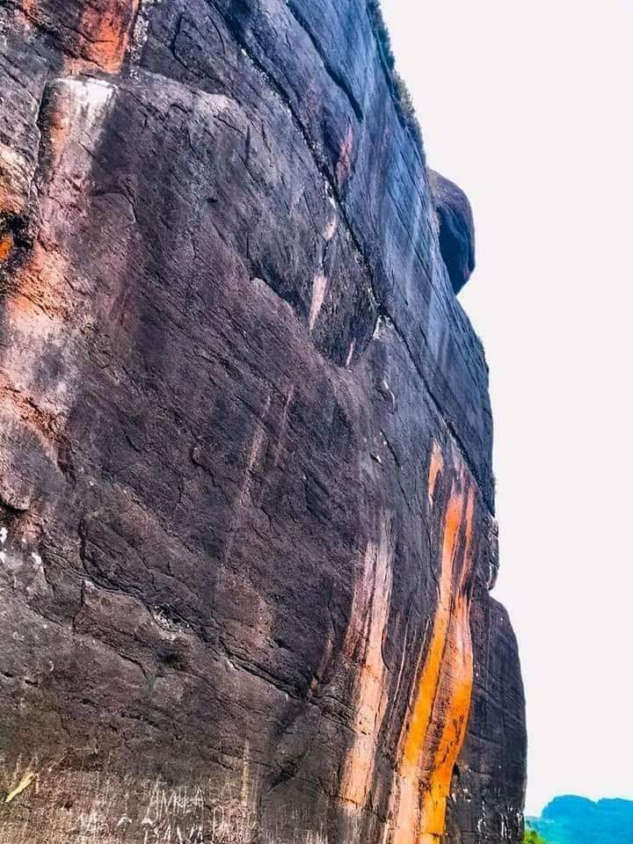

Figure

# 

# Topographic Features of Rakshagala Mountain.

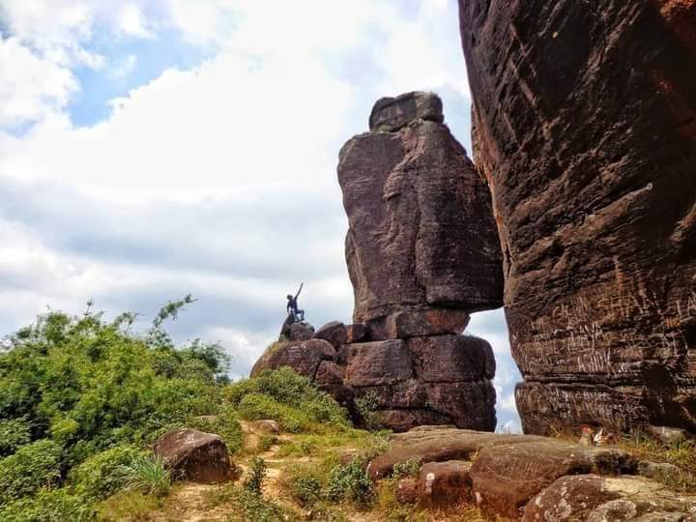

Figure

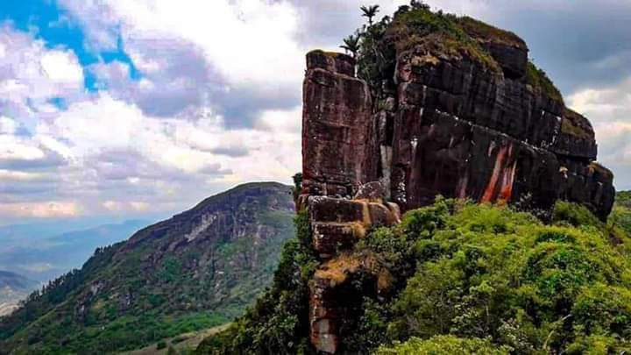

Figure

**It** is important to study the topography of this Rakshagala Mountain, Which is said to be an iron factory of king Ravana.That is, this Rakshagala or Kinihira Mountain is located on the south – west slope of the central mountains. The topography of this mountain is diverse. There are slight slopes in some places and steep slopes in other places. People visiting this monstrous mountain should tread carefully. There are steep slopes on the way, so you have to walk on a flat ground for a short distance. This area consists of convex slopes and concave slopes. In particular, wind cone can be seen among the topography of Rakshagala Mountain. Also, the topography of this area around Rakshagala Mountain is very strange because there is a swamp in the middle of the forest and a valley is also located near the swamp. The rocks are of different heights. The height of this mountain is believed to be around 1438m.When you climb to the top of the mountain, you look at the environment below from a very high place.

# Biodiversity of Rakshagala area.

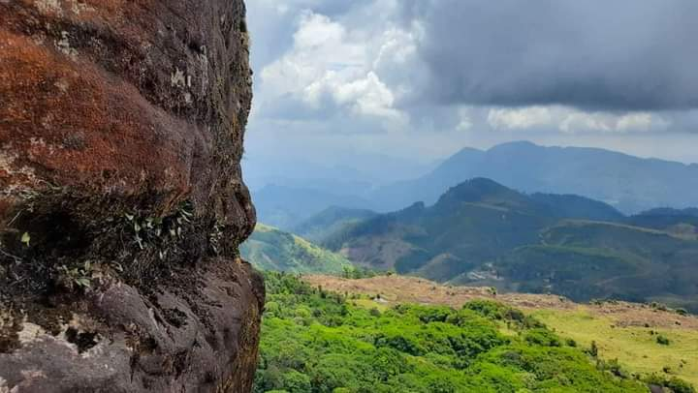

Figure

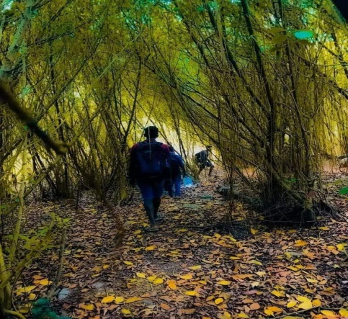

Figure

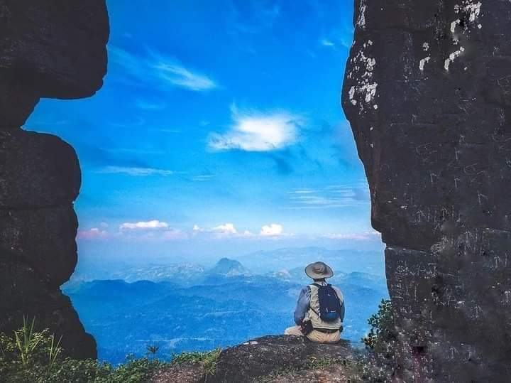

Figure

All the plants and animals living on earth and the ecosystems they live in area called “biodiversity”. There is a great diversity in the ecosystem around Rakshagala Mountain .This is located on the south – west slope of the central mountains. The forests including this Rakshagala Mountain belong to the category of “dwarf forests”. IN the study of plant diversity in the vicinity of Kinihira Mountain, it is full of rich biodiversity. Mount Rakshagala belongs to the mountainous wet zone. It rains throughout the year. The average rainfall is about 3500mm.The villages including this area get dry winds from December to February .Average temperature is around 20oC.The form of the plants found here is wet bundles. It also has a twisted and branched nature directed in one direction. IN some places the plants are in a bunch and in other places they are thin. There are many types of herbs in this Rakshagala Mountain, such as Hathawariya, Maharathmal, Sadaraja, Iraraja, Gururaja, Mill Avariya, Kadulassa, and Ankinda, Heenbovitiya

## Maharathmal.

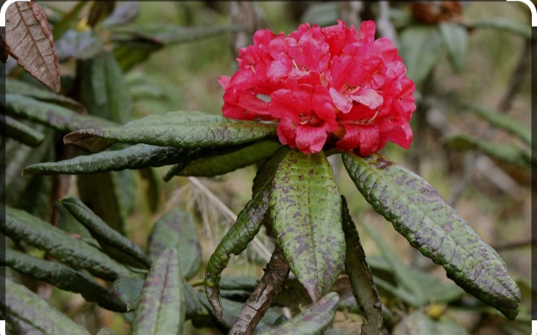

Figure

## **Kadulassa**.

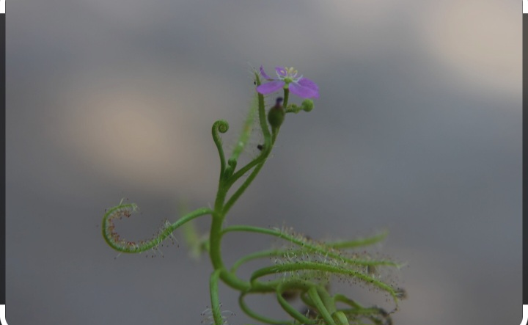

Figure

Many types of plants such as bamboo and thorn can be seen while visiting these area. Many kinds of plants such as bamboo and thorn can be seen when visiting this area; the thorn plant is unique to this Rakshagala site. It is also special to see such plants in a climate that receives more than 3000mm of rain. It was.

In addition to these plants, other plants were also seen in the Rakshagala site area. The plants here are not grown with a canopy and you can also see that the plant stems are open. Furthermore, since the plant stems are wet, other small plants have grown on those plant stems. You can see many plant stems like “Ferns”. Also, when you reach the top of the mountain, the plants small leaves are also characteristic of this. The plants on this hill are not that tall and are about 10-15mm tall. Plants have also grown on the tops of the rocks. Because the water drops down from the tops of those rocks, you can see a species of “algea”on those rocks.

* Ferns. 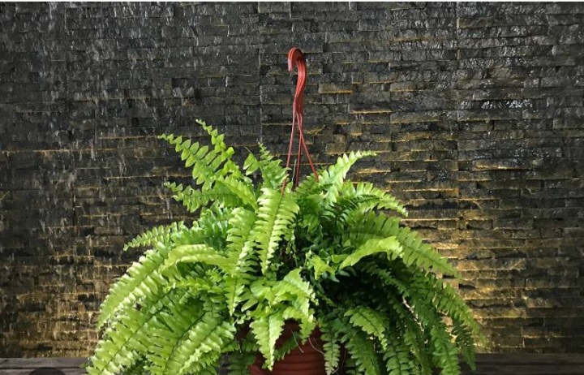

Figure

The types of trees that exist in the Rakshagala area are the plants that grow in the humid region climate, such as waddle (Artocarpuanobitis), Mango (Mangifere zelenica), and pomegranate (callophyllum inophyllum), Godapara (dilenia retusa), millet (vitex piñata), banyan (Focus bengalensis), tamarind (it can be seen that there are species of plants such as tamarindus indica), kohomba, Veralu, Kanda, erabadu, and a little above the foot of the mountain are plants. It is special to be able to see understory cultivation in this area because the sunlight falls on the ground according to the way these plants are grown.

## Mango.

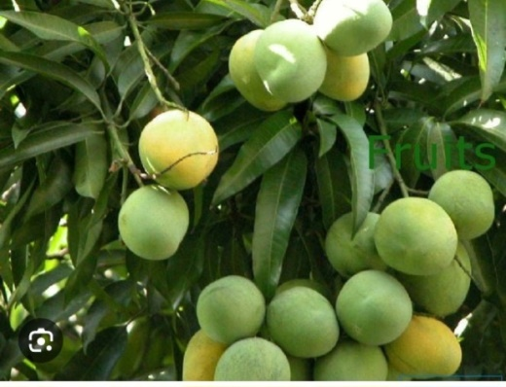

Figure

## Banyan trees.

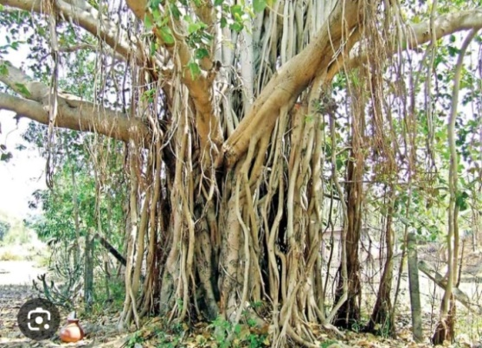

Figure

## **Phineas nuts**.

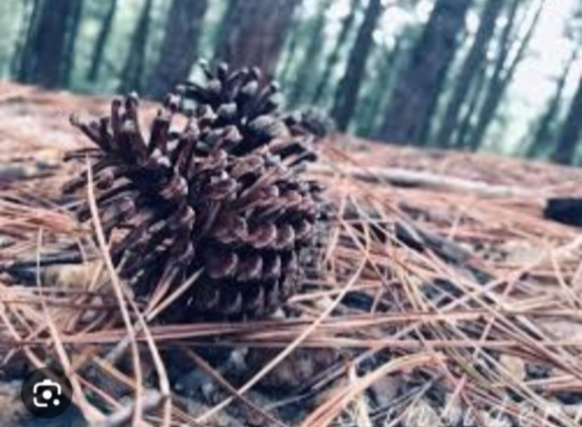

Figure

## Veralu.

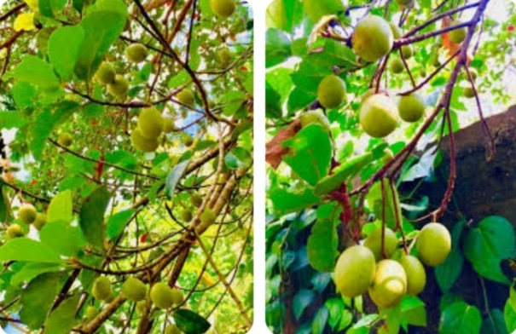

Figure

Plant varieties.

***A***

Variety of plants is found in the different climate zones found in the Rakshagala area. That is “Orchids “that grow under arid climate condition can also be seen in places around this area. Grass plants could also be seen in this area. Due to the effect of winds, there is a dry condition is some places here. For that reason, the grass plants called “Lev”in the Rakshagaala area, and many types of grasses such as illuk, mana, ginitrina , etc. Can be seen in the area around the mountain. Also, depending on the plant diversity. We can see invasive plant species in some places of this Rakshagala site. While studying the plant diversity of the area around Rakshagala Mountain or Kinihira Mountain, it is possible to see various types of plants. Until now, the forest can be called a terrestrial area belonging to the forest. That is, plants with branched strong stems convert with bark, plants such as maharathmal, heenbutia, grasses and understory plants. It has been possible to see species of plants, medicinal plants, grass plants, invasive plants etc.in this Rakshagala area. Therefore, the plant diversity in this area is very high.

## Mana plants.

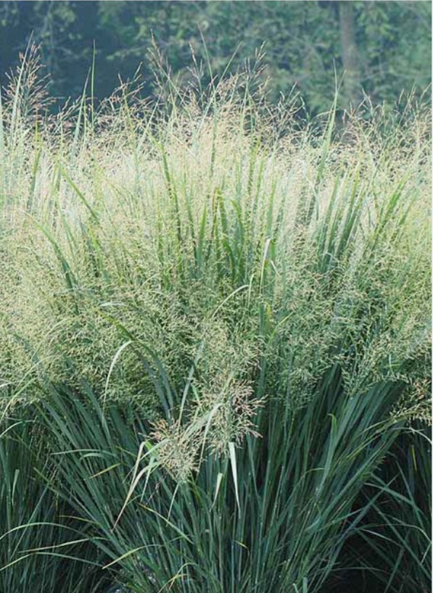

Figure

## Heinbovitiya.

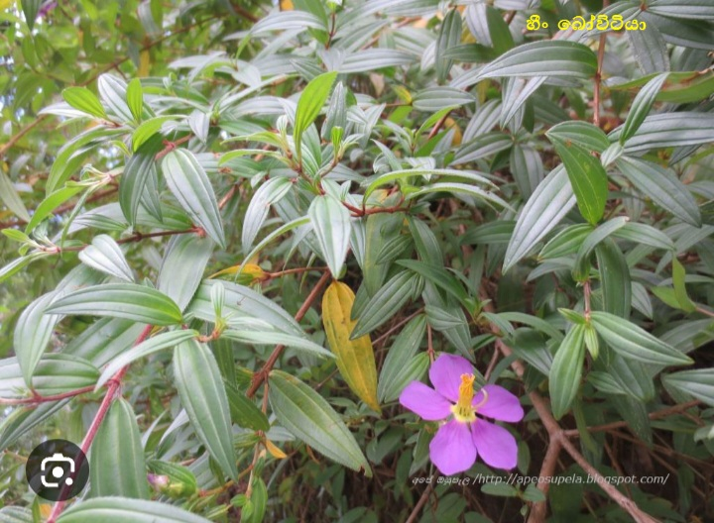

Figure

# Animal Diversity.

***A***

lso, under biodiversity, in addition to plant diversity, animal diversity is high in this area. Several animal species could be seen in the forests if Rakshagala mountain area. Several species of animals were seen in the forest of Rakshagala area, such as green leopard, deer, squirrel, monkey, snail, moose and special butterflies. A large number of animals such as parrot, owl, can be seen in this Rakshagala mountain site. When you ask about living things and reptiles, the frog and leeches found in this area are also special among them. Leeches can be seen very much in this area. The specialty of the leeches is that the leeches in this kinihira mountain have a green stripe on their backs. Monkeys can be seen in large numbers in the Rakshagala area. They can be seen living in herds.

* Purple faced languor.

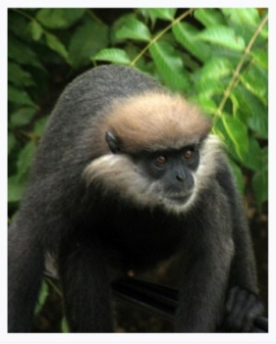

Figure

The purple faced langur, also known as the purple faced green monkey (Trachypithecus vetulus), is an ancient monkey species native to srilanka.This animal has a long tail. Identified by a mostly brown complexional dark face (with a pale face below) and a very shy nature. The species was once abundant in the suburbs of Colombo and in “wet zone “villages (areas with high temperature and high humidity throughout the year, where rains flood during the monsoon season), but has begun to die out rapidly due to rapid urbanization. It was traditionally classified in the lutung genus Trachypithecus, but was moved to the genus semnopithecus based on DNA evidence showing it was more closely related to gray langurs.

## Monky.

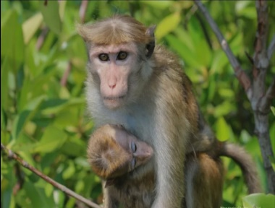

Figure

Monky is the most widespead in srilanka.Monkyes are also mostly found in this area.Monkey are divided into 3 parts according to the climatic zones of the island.In this area,the relawn live in heads in the mountainous redion.They are omnivorous.They are the most common animal species in this area.

## Giant Squirrels.

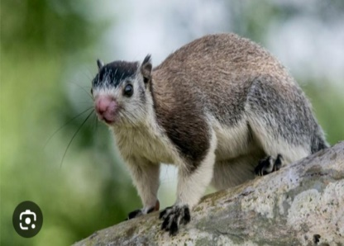

Figure

Among the animal species,the national animal, the giant squirrel is widely found in this area.Scientific name of giant squrrel is “Ratufa Maderiya”.giant squirrel is species can be seen in the central and western regions of Srilanka.The 25cm long stickleback has a long tail and round short ears and broad hands.Brown, red, gray and black colour can be seen on the body.It can even jump from one tree to a treee thatis 6cm away.

The national bird of srilanka is known by the scientific name of gallus lafayetii.Jungleflow is a local bird native to our country.It lays only 2 to 4 egg at a time in a nest made on the ground under a tree stump or under grass.This national bird can be seen in Rakshagala area.

## Jungleflow.

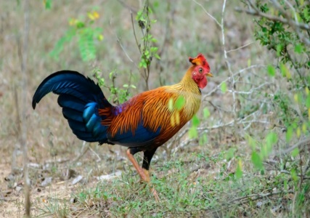

Figure

## Myna.

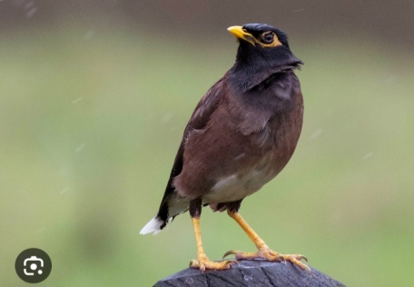

Figure

# A beautiful creation of nature.

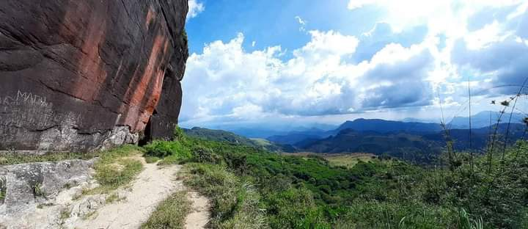

Figure

**The** main factory that affects human existence is oxygen gas.**Oxygen gas is obtained by human as a by_product of the plant’s photosynthesis**.the process called photosynrhesis affects the production of more gas.



Figure

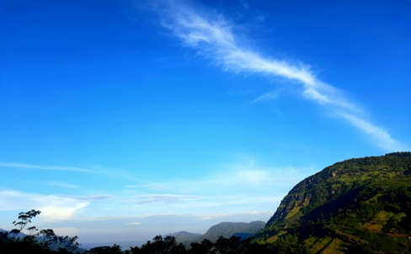

Figure

# Aim of my project.

* The main goal of my project is to see that such beautiful and mind_blowing places become a valuable topic of discussion in this country as well as among foreugners.This station should be one more foundation to further develop the tourism project which is the most important source of income of our country.The only purpose of this Article is to make this mountain of historical value called Rakshagala a famous station for tourists from all over Srilanka as well as to the whole world, as well as to make it a beautiful tourist paradise………………………..

# All of the location details.

|  |  |  |  |  |  |  |  |  |  |  |  |  |
| --- | --- | --- | --- | --- | --- | --- | --- | --- | --- | --- | --- | --- |
| |  |  | | --- | --- | | 1. Name of the place | Rakshagala mountain. | | 1. location | rakshawa/dolosbage. | | 1. importance | Historical significant. | | 1. The height of the hill | 1438M. | | 1. LAND SIZE | ABOUT 450 ACRES. | | 1. OTHER NAME | Kinihira mountain. | |

# 

# Referenses.

You tube (Travelling page)

* Dinesh & pathum.
* Lokaya with Sube.
* YAKK PRODUCT.
* Thushara Gallage.

Facebook Page.

* Queen of the World(photos).
* Live Deniyaya page.
* Unseen SENSE.
* Travel Trinco.

Vlogs (Travelling).

* The Travelling Squad.
* Yakdessa vlog.

Thank you,

Naw/it/2022/f/0011

L.G.T.amanthika kumari.